
Dr. D.Y. Patil School of MCA
Charoli (BK), PUNE- 412105



SAVITRIBAI PHULE PUNE UNIVERSITY MASTER OF COMPUTER APPLICATION

Project Report on Blog Platform with CMS

BY

Student Name: Lokesh Patil
Roll No: 25234
Under The Guidance of Prof. Dr. Zameer A.S Mulla

MCA-I(Sem-I)

2025-26

Year: 2024-2025


Date: 24/December/2025

Certificate

This is to certify that Lokesh Raju Patil, Roll No. 25234 a student of Dr D Y Patil School of MCA, has successfully completed the project entitled Blog Platform With CMS in partial fulfilment of the requirements for the MCA- Mini Project (Semester I) during the academic year 2025–2026.

Prof. Dr. Zameer A.S Mulla Prof. Sapna Chavan Dr E B Khedkar Project Guide HOD – MCA Director

ACKNOWLEDGEMENT

I acknowledge to all those who have been so helpful in my academic project work. Nevertheless, I have tried through this report to express my deepest gratitude to all those who have given their precious time, skill, knowledge, valuable advice and guidance and facilities.

At the very outset I take opportunity to express my deepest gratitude and thanks to Director of our College Dr. E. B. Khedkar and Prof. Sapna Chavan–HOD and other teaching and non- teaching staff for their useful guidance during the completion of this project report.

I am highly obliged to Prof. Dr. Zameer A.S Mulla - Project Guide - for his valuable guidance and encouragement given to complete the project. His guidance has certainly helped me to simplify the difficulties and finalize the system effectively.

Last but not the least I thank to my almighty God, Parents and friends for their constant support to me in all aspects during work.

Thank You,
Lokesh Patil
MCA – I (Sem-I)
Dr D Y Patil School of MCA

INDEX
Sr.  No. | Title | Page No.
1 | Chapter 1: Introduction | 5-6
1.1 | Abstract | 5
1.2 | Existing System and Need for System | 5
1.3 | Scope of System | 5
1.4 | Operating Environment - Hardware and Software  Brief Description of Technology Used | 6
1.5 | Operating systems used (Windows or Unix), RDBMS/No SQL used  to build database (MySQL/oracle, Teradata, etc.) | 6
1.5.1 | Operating systems used (Windows or Unix) | 6
2 | Chapter 2: Proposed System | 6-9
2.1 | Feasibility Study | 6
2.2 | Objectives of Proposed System | 7-9
2.3 | Users of System
3 | Chapter 3: Analysis and Design | 10-20
3.1 | System Requirements (Functional and Non-Functional requirements) | 10
3.2 | Entity Relationship Diagram (ERD) | 11
3.3 | Table Structure | 12
3.4 | Use Case Diagrams | 13
3.5 | Class Diagram | 14
3.6 | Activity Diagram | 15
3.7 | Sequence Diagram | 16
3.8 | Deployment Diagram & Module Hierarchy Diagram | 17
3.9 | Sample Input and Output Screens. | 18-20
4 | Coding | 21-25
4.1 | Algorithms | 21-23
4.2 | Code snippets | 24-25
5 | Testing | 26-27
5.1 | Test Strategy | 26
5.2 | Unit Test Plan | 26
5.3 | Acceptance Test Plan | 27
5.4 | Test Case / Test Script | 27
5.5 | Defect report/Test Log | 27
6 | Limitations of Proposed System | 28
7 | Proposed Enhancements | 29
8 | Conclusion | 29
9 | Bibliography | 30

1. Introduction

1.1 Abstract
This project aims to develop a Blog Platform with CMS, allowing users to register, create, edit, and delete blog posts seamlessly. The platform offers a rich content creation experience using a markdown editor and supports reader interaction through comments. The application emphasizes user-friendliness alongside SEO-friendly technology to improve content visibility and user engagement.

1.2 Existing System and Need for the System
With the increasing demand for personalized digital content, blogging platforms serve as essential tools for individuals and organizations to share ideas, stories, and expertise. Many existing platforms are either restrictive in content presentation or lack optimal SEO capabilities. This system aims to fill those gaps by delivering a flexible, SEO-optimized blogging platform built with modern technologies.

1.3 Scope of the System
The platform will provide the following features:
- User registration and authentication
- Creation, editing, and deletion of blog posts by authenticated users
- Rendering of posts written in markdown format
- Commenting functionality accessible to both visitors and authenticated users
- A responsive user interface compatible with desktops, tablets, and smartphones
Note: Administrative functionalities like post moderation and user management are not included in this
phase.

1.4 Operating Environment
- Hardware: Any device with internet access and a modern web browser (e.g., desktops, laptops, tablets, smartphones)
- Software:
  - Operating System: Platform-independent (Windows, macOS, Linux/Unix) as the application is web-based
  - Frontend: Next.js (React framework) providing SEO-friendly server-side rendered pages
  - Backend: Python (Flask) serving RESTful APIs
  - Database: MongoDB, a NoSQL database offering flexible schema design

1.5 Brief Description of Technology Used
- Next.js: A React-based framework enabling server-side rendering and static site generation to enhance SEO and performance.
- React Markdown: Parses and safely renders markdown content in the frontend UI.
- Python Web Framework (Flask): Handles backend logic, API routing, and user authentication.
- PyMongo: Python libraries used to connect and interact with MongoDB.
- MongoDB: NoSQL database designed for storing JSON-like documents, ideal for flexible blog post and comment structures.

2. Proposed System

Study of Similar Systems
Popular blogging platforms such as WordPress and Medium offer extensive features but often come with heavy dependencies, limited customization, or proprietary restrictions. This system leverages modern frameworks like Next.js and Python-based backends with MongoDB to deliver a dynamic, user-authenticated blogging experience that is both SEO-friendly and highly customizable.

2.1 Feasibility Study
- Technical Feasibility: Utilizes mature, widely adopted technologies with strong community support, enabling straightforward development and deployment.
- Economic Feasibility: All core tools are open source, minimizing costs. Cloud hosting options for MongoDB (like Atlas) offer free tiers, keeping operational costs low.
- Operational Feasibility: The system’s intuitive UI and clear functionalities ensure user acceptance and easy maintenance.

2.2 Objective of Proposed System
- Deliver a seamless, SEO-optimized blogging platform using modern frontend and backend technologies.
- Enable users to create formatted content efficiently via markdown.
- Foster community engagement through comments on posts.
- Securely manage user authentication and personalized content.

Module Specifications
- User Authentication Module:
Facilitates secure registration, login, and session management for users using Python backend solutions.
- Post Management Module:
Allows authenticated users to create, update, delete, and retrieve blog posts stored in MongoDB in markdown format.
- Markdown Rendering Module:
Converts markdown to HTML for frontend display using React Markdown.
- Commenting Module:
Permits users and visitors to add comments on blog posts, with data stored and managed in the database.
- Frontend UI Module:
Implements a responsive, accessible interface with Next.js and styling frameworks like Tailwind CSS.

2.3 Users of the System
- Registered Users: Can create, edit, delete their own blog posts and comment on any posts.
- Visitors: Can read posts and submit comments, with optional authentication for improved moderation in future updates.

3.1 System Requirements
System requirements define what the system should do and how well it should perform.
They are divided into Functional Requirements and Non-Functional Requirements.
3.1.1 Functional Requirements
Functional requirements describe the core features and services provided by the Blog Platform with CMS.

FR1: User Registration
- The system shall allow new users to create an account using valid credentials.
- Duplicate usernames or email IDs shall not be allowed.

FR2: User Login and Authentication
- The system shall authenticate users using secure login credentials.
- Only authenticated users shall be allowed to create, edit, or delete blog posts.

FR3: User Logout
- The system shall allow logged-in users to securely log out of the application.

FR4: Blog Post Creation
- The system shall allow authenticated users to create blog posts.
- Blog content shall be written in Markdown format.
- Each post shall include title, content, author, and creation date.

FR5: Blog Post Editing
- The system shall allow users to edit only their own blog posts.
- Updated content shall be saved and reflected immediately.

FR6: Blog Post Deletion
- The system shall allow users to delete their own blog posts.
- Deleted posts shall be removed from public view.

FR7: View Blog Posts
- The system shall allow visitors and registered users to view published blog posts.
- Blog posts shall be rendered in readable HTML format from Markdown.

FR8: Commenting System
- The system shall allow users and visitors to add comments on blog posts.
- Each comment shall store commenter name, comment text, and timestamp.

3.1.2 Non-Functional Requirements
Non-functional requirements describe quality attributes, performance, and constraints of the system.

NFR1: Performance
- The system shall load blog pages efficiently with minimal delay.
- API responses shall be optimized for fast data retrieval.

NFR2: Security
- User passwords shall be stored in encrypted or hashed format.
- Unauthorized access to protected resources shall be restricted.

NFR3: Scalability
- The system shall support an increasing number of users and blog posts without major performance degradation.

NFR4: Reliability
- The system shall ensure data consistency for posts and comments.
- In case of system failure, data shall not be lost.

NFR5: Usability
- The system shall provide a simple and intuitive user interface.
- Users with basic technical knowledge shall be able to operate the system easily.

Database Design Verification

Table 1: Users

Field Name | Data Type | Description
_id | ObjectId | Unique identifier for each user
username | String | Username of the user
email | String | Email address of the user
password | String | Encrypted password
reset_password_token | String | Token for password reset
reset_password_expires | Timestamp | Password reset expiry time
created_at | Timestamp | Account creation date

Table 2: Posts
Field Name | Data Type | Description
_id | ObjectId | Unique identifier for each post
title | String | Title of the blog post
body | Text | Blog content (Markdown)
author_id | ObjectId | Reference to Users table
tags | Array | List of tags
image | String | Featured image URL
created_at | Timestamp | Post creation time
updated_at | Timestamp | Last updated time

Table 3: Comments

Field Name | Data Type | Description
_id | ObjectId | Unique identifier for comment
body | Text | Comment content
post_id | ObjectId | Reference to Posts table
author_id | ObjectId | Reference to Users table
parent_id | ObjectId | Parent comment ID (for replies)
created_at | Timestamp | Comment creation time
updated_at | Timestamp | Last update time

Table 4: Post_Likes
Field Name | Data Type | Description
_id | ObjectId | Unique identifier
post_id | ObjectId | Reference to Posts table
user_id | ObjectId | Reference to Users table
created_at | Timestamp | Like timestamp

ERD Diagram

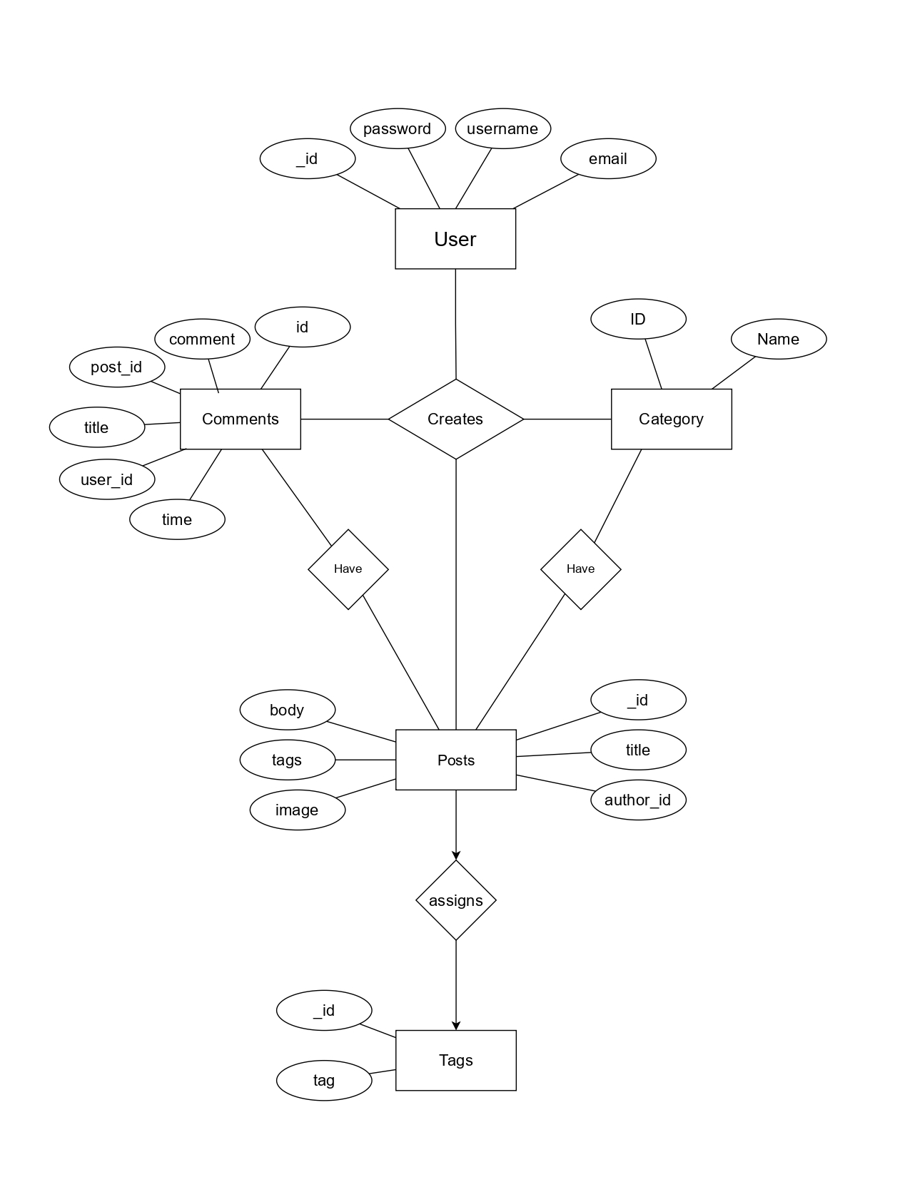

UML Diagrams
- Class Diagram

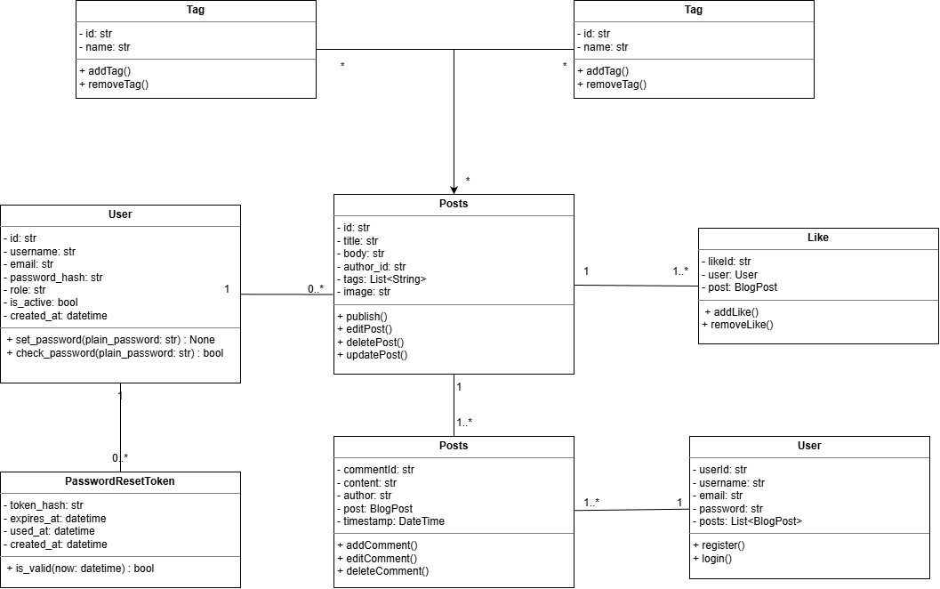

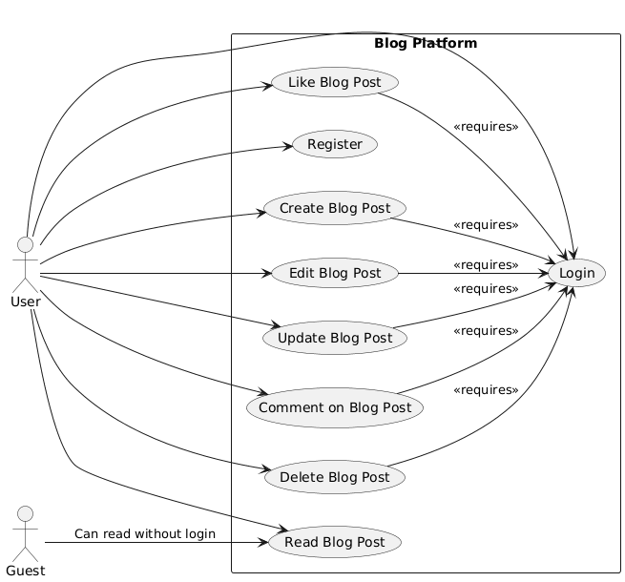
2. Use Case Diagram

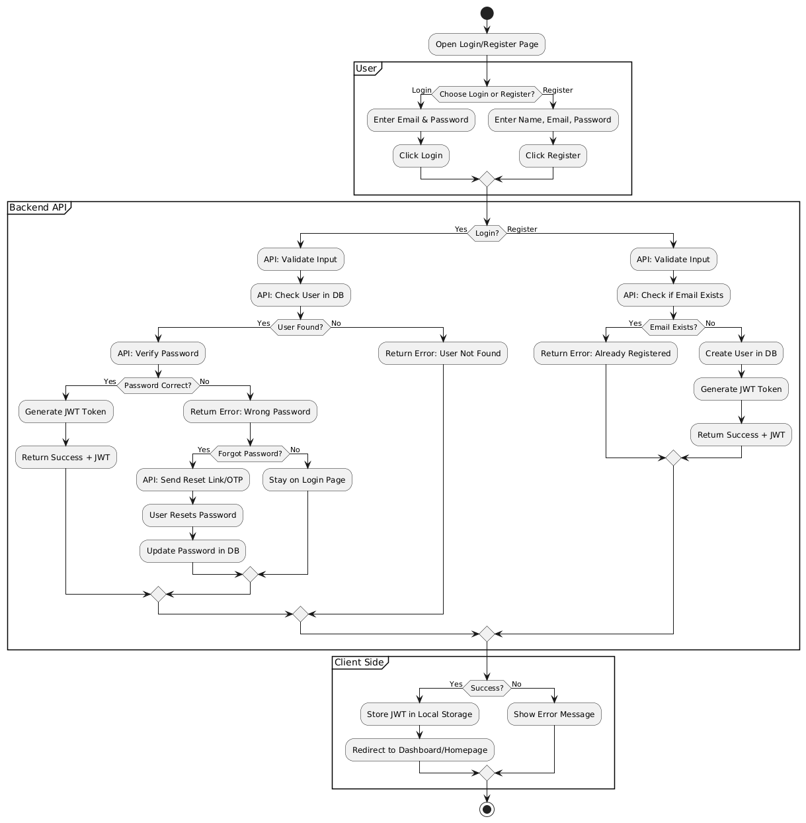
- Activity Diagram
-Login Register

-Post Activity Diagram

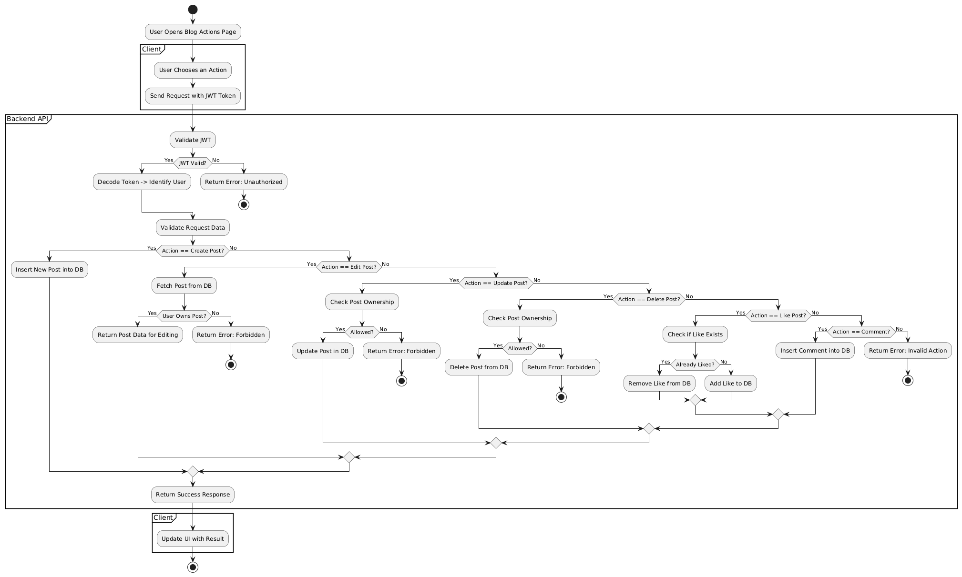

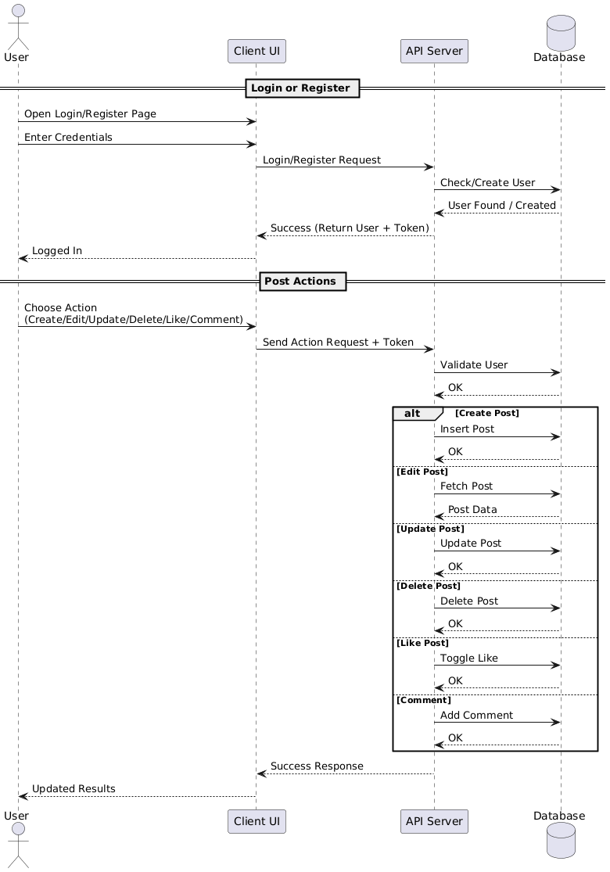
- Sequence Diagram

- Deployment Diagram & Module Hierarchy Diagram

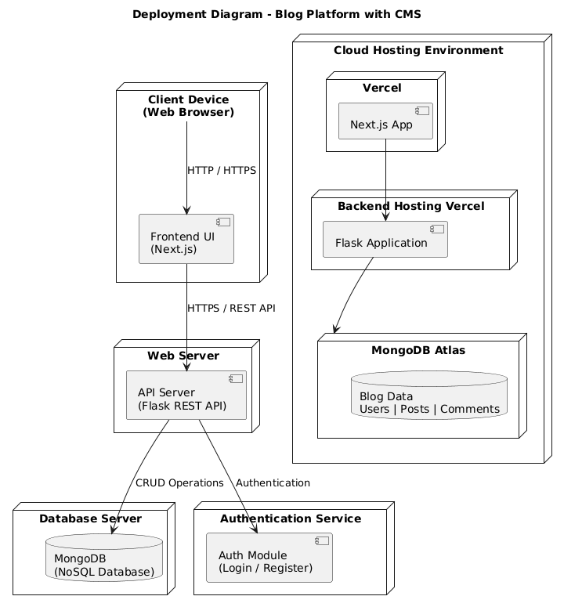

3.5 Sample Input and Output Screens

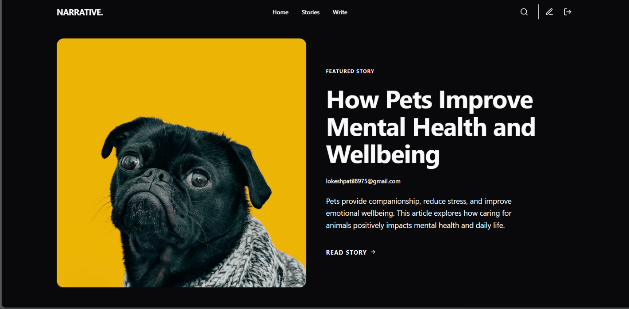

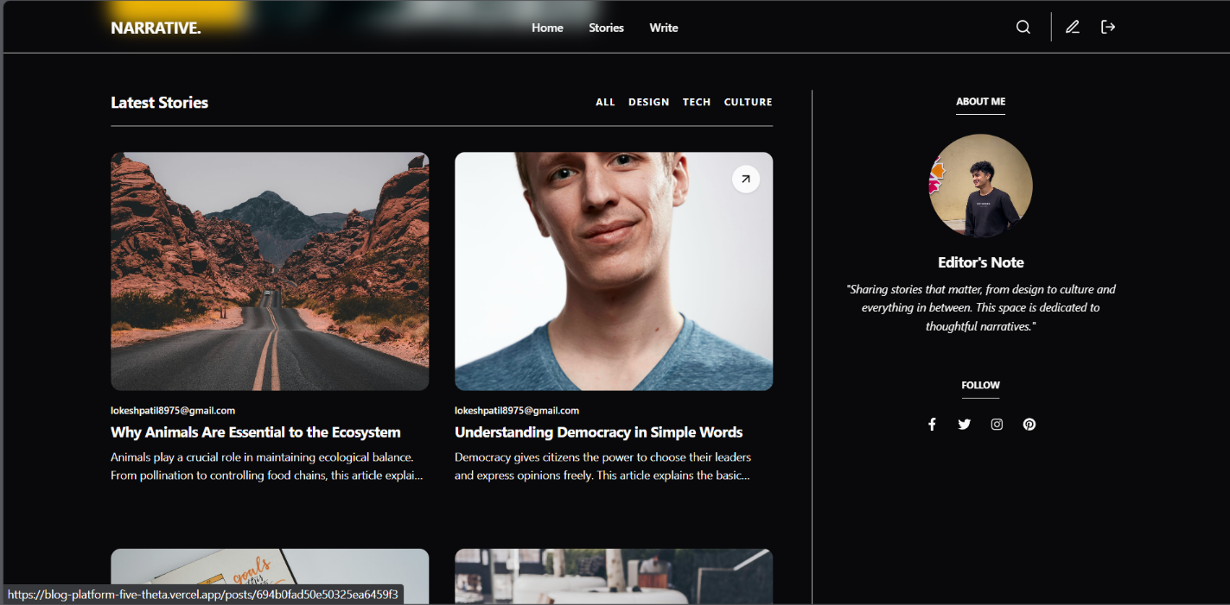

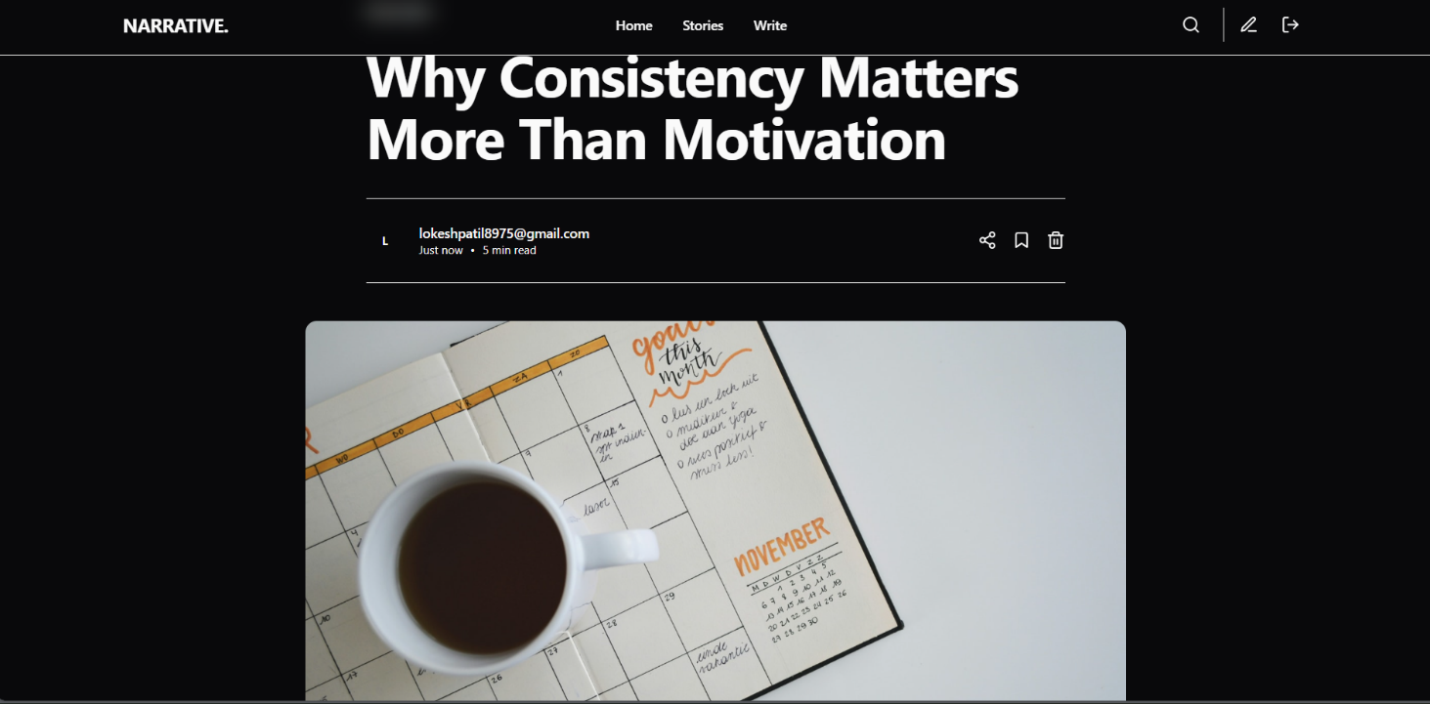

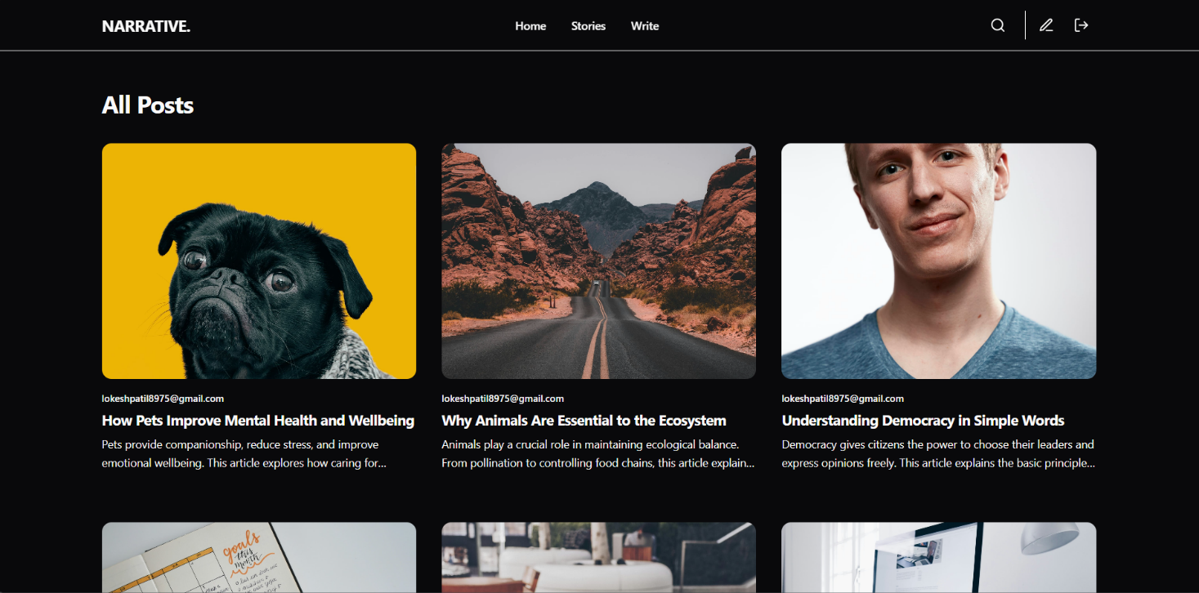

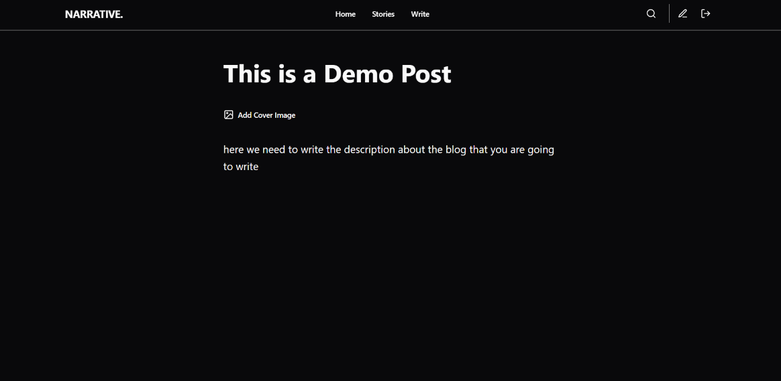

- Coding

4.1 Alogorithm

Algorithm 1: User Registration
Input: Username, Email, Password
Output: User account created successfully or error message
Steps:
- Start
- Accept user registration details
- Check whether email or username already exists
- If exists, display error message and stop
- Encrypt the user password
- Store user details in the database
- Display registration success message
- End

Algorithm 2: User Login
Input: Email, Password
Output: Login success or failure

Steps:
- Start
- Accept login credentials
- Retrieve user details from database
- Compare entered password with stored encrypted password
- If credentials match, generate authentication token
- Allow user access to the system
- Else display login error
- End

Algorithm 3: Create Blog Post
Input: Post title, Content (Markdown), Author ID
Output: Blog post saved successfully
Steps:
- Start
- Verify user authentication
- Accept post title and markdown content
- Validate input fields
- Store post data in database
- Display post creation success message
- End

Algorithm 4: Edit Blog Post
Input: Post ID, Updated content
Output: Post updated successfully
Steps:
- Start
- Verify user authentication
- Fetch post using Post ID
- Check whether user is the author
- Update post content in database
- Save updated timestamp
- Display confirmation message
- End

Algorithm 5: Delete Blog Post
Input: Post ID
Output: Blog post removed
Steps:
- Start
- Verify user authentication
- Identify post using Post ID
- Check user authorization
- Delete post from database
- Display deletion success message
- End

Algorithm 6: View Blog Posts
Input: None
Output: List of published blog posts
Steps:
- Start
- Fetch all published posts from database
- Convert markdown content to HTML
- Display posts on user interface
- End

4.2 Code Snippet
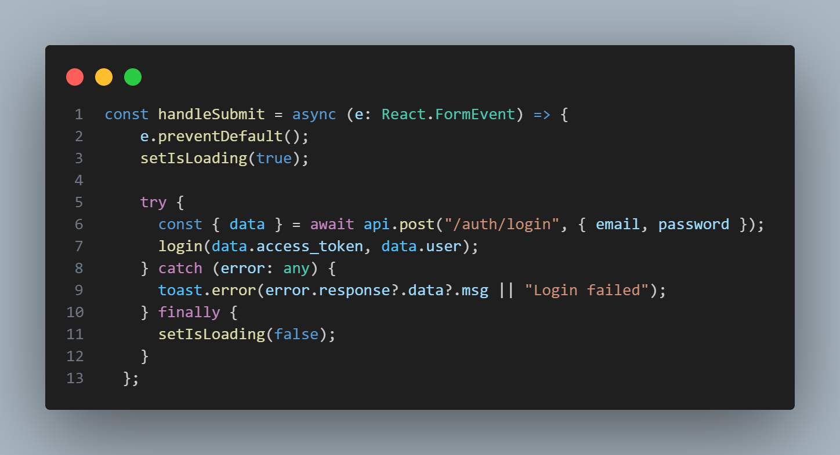
  - Login Code Snippet

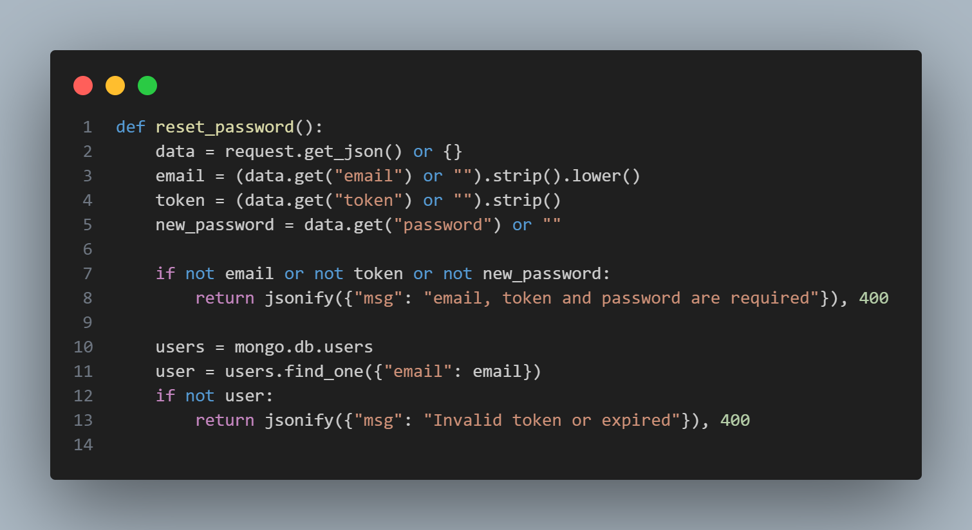
  - Reset Code Snippet

  - Token Generation
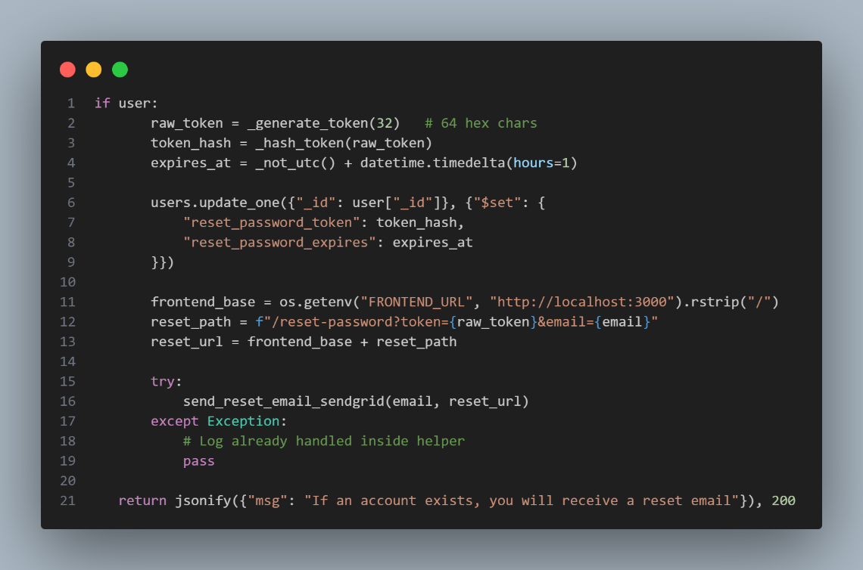

  - Submit Reset Token

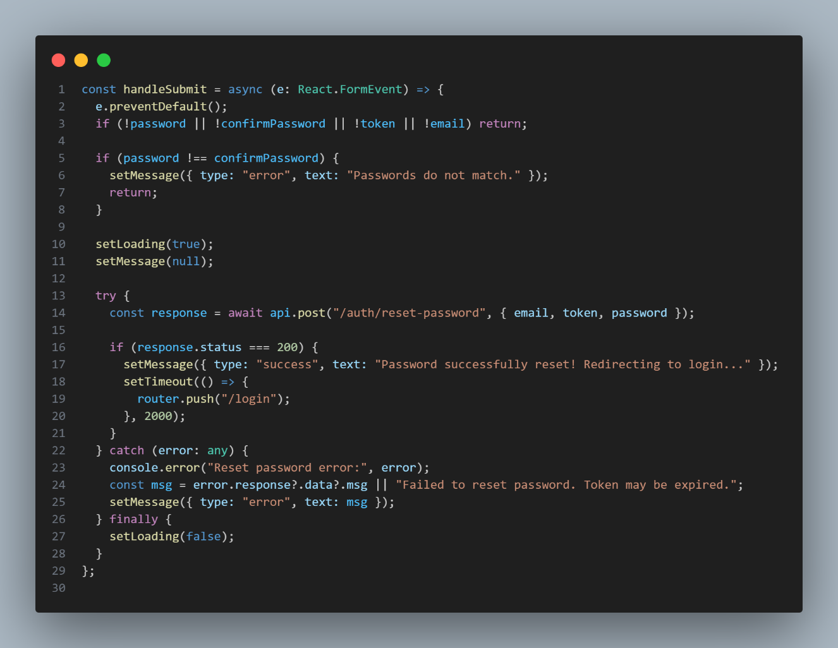

5. Testing
Testing is performed to ensure that the Blog Platform with CMS works correctly and meets the specified requirements.

5.1 Test Strategy
- Manual testing is used for system validation.
- Functional and integration testing are performed.
- Both valid and invalid inputs are tested.
- Frontend and backend interaction is verified through APIs.

5.2 Unit Test Plan
- Individual modules are tested separately.
- User authentication, post management, and comment modules are tested.
- Each module is verified for correct input and output.

5.2 Unit Test Plan
- Individual modules are tested separately.
- User authentication, post management, and comment modules are tested.
- Each module is verified for correct input and output.

5.4 Test Case / Test Script
Test Case ID | Description | Expected Result | Status
TC_01 | User Registration | Account created | Pass
TC_02 | User Login | Login successful | Pass
TC_03 | Create Post | Post created | Pass
TC_04 | Edit Post | Post updated | Pass
TC_05 | Delete Post | Post deleted | Pass
TC_06 | Add Comment | Comment added | Pass

5.5 Defect Report / Test Log

Defect ID | Description | Status
D_01 | API configuration issue | Fixed
D_02 | CORS error | Fixed

6. Limitations of Proposed System
Although the Blog Platform with CMS fulfills the essential requirements of a modern blogging application, it has certain limitations due to project scope, time constraints, and academic focus.
- Limited Administrative Control
The current system does not include an admin panel for content moderation, user management, or comment approval. All users operate with the same level of access.
- Basic Authentication Mechanism
The authentication system is limited to basic login and registration. Advanced security features such as two-factor authentication, OAuth-based login, and account recovery mechanisms are not implemented.
- No Role-Based Access Control
The system does not differentiate users based on roles such as admin, editor, or moderator. Role-based permissions are considered out of scope for the current version.
- Limited Comment Moderation
Comments posted by visitors or users are not filtered or moderated automatically. This may allow inappropriate or spam content until manual intervention is introduced in future enhancements.
- Scalability Constraints
While MongoDB supports scalability, the current deployment and backend configuration are suitable only for small to medium traffic and may require optimization for large-scale usage.
- Limited Analytics and Reporting
The system does not provide analytics such as post views, user engagement statistics, or performance reports.

7. Proposed Enhancements
The Blog Platform with CMS can be further improved by incorporating additional features and advanced technologies in future versions. These enhancements aim to increase usability, security, scalability, and overall system efficiency.
- Administrative Panel
An admin dashboard can be introduced to manage users, blog posts, and comments. This would allow content moderation, user role management, and system monitoring.
- Role-Based Access Control
Different user roles such as admin, editor, and author can be implemented to provide controlled access to system functionalities.
- Advanced Authentication Mechanisms
Security can be enhanced by adding features such as two-factor authentication, email verification, password recovery, and OAuth-based login using third-party services.
- Improved Comment Moderation
Automated comment filtering and approval mechanisms can be added to prevent spam and inappropriate content.
- Advanced Search and Filtering
Features such as full-text search, tag-based filtering, category-wise browsing, and sorting of posts can be implemented for better content discovery.
- Analytics and Reporting Module
An analytics module can be developed to track post views, user engagement, comment activity, and system usage statistics.
- Performance Optimization and Caching
Caching mechanisms and performance optimization techniques can be applied to improve response time and handle higher traffic loads efficiently.
- Cloud Deployment and Scalability
The system can be deployed using scalable cloud infrastructure with load balancing to support large numbers of users and high availability.

8. Conclusion
The Blog Platform with CMS is a web-based application designed to provide a simple and efficient solution for creating, managing, and publishing blog content. The system successfully integrates modern frontend and backend technologies to deliver a user-friendly, responsive, and SEO-friendly blogging experience.
By using Next.js for the frontend and Flask for the backend, the application ensures fast page rendering, secure API communication, and smooth interaction between system components. The use of MongoDB as a NoSQL database provides flexibility in handling blog posts and comments with varying structures.
The platform enables registered users to create, edit, and delete blog posts using Markdown, while visitors can easily read posts and interact through comments. The modular architecture and clean separation of concerns make the system easy to understand, maintain, and extend.
Overall, the project meets its defined objectives and demonstrates the practical application of web development concepts, database design, and software engineering principles. The system serves as a strong foundation for future enhancements and can be further extended to support advanced features such as role-based access control, analytics, and large-scale deployment.

- Bibliography
• MongoDB Documentation,
https://www.mongodb.com/docs/
• Flask Official Documentation,
https://flask.palletsprojects.com/
• Next.js Documentation,
https://nextjs.org/docs
• React Documentation,
https://react.dev/
• Tailwind CSS Documentation,
https://tailwindcss.com/docs

